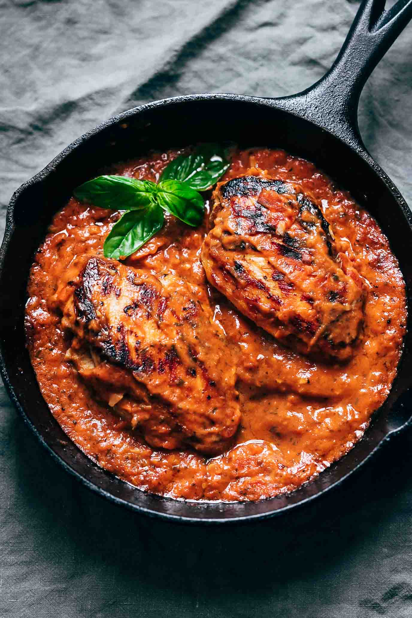
Creamy Tomato Basil Chicken

Prep Time 10 min Cook Time 25 min
4 Servings
Ingredients
4 Tbsp olive oil
1 Tbsp minced Garlic
1 lb chicken breasts
5 Roma tomatoes, diced
¾ cup chicken broth
1 cup basil leaves
¾ cup heavy cream
Directions
- Add olive oil and garlic to a skillet and heat gently to infuse the olive oil with garlic flavor.
- Once the garlic is a light golden color, season the chicken breasts on both sides with salt and pepper and slide them into the pan. Sear on both sides and cook for 10 minutes in the pan or till the chicken breast is cooked through.
- Take the chicken breasts out of the pan and place them on a plate.
- Add tomatoes and broth to the pan, along with salt and cook for 8-10 minutes until the tomatoes have broken down completely and are mushy and have formed a thick sauce.
- Add basil and cream and mix well. Add the chicken breast.

